ECS767P Emerging Topics in Machine Learning and Computer Vision, 2019

**Course Work 2:**

**Unsupervised Learning by Generative Adversarial Network**

1. **What is the difference between supervised learning & unsupervised learning in image classification task?** **(10% of CW2)**

**Supervised learning requires labeled data. The model is trained to take an input, such as an image and output the label for it.**

**Unsupervised learning does not have labeled data and the objective is therefore not to recreate a label. Instead it tries to identify some underlying structure in the data e.g. clustering or a latent vector representation. In image classification the latent vector representation is one of the most commonly used.**

1. **What is the difference between an auto-encoder and a generative adversarial network considering (1) model structure; (2) optimized objective function; (3) training procedure on different components. (10% of CW2)**

(1) Auto-encoders have two main components, the encoder and the decoder. The encoder converts the image to a latent vector. The decoder converts the latent vector back to an image. A GAN does not have these components. Instead the GAN starts with a latent vector sampled from a noise prior. The generative function (G) converts the latent vector to an image. The discriminator network takes images (some from the generators output and others from real data) and outputs the probability that the image was created by the generator and not sampled from the real images.

(2) The autoencoders objective is to optimise the loss function which is calculated as the difference between the input and the output images (typically MSE). This means its optimised objective function is 0, when it achieves 0 loss and the output image is identical to the input image.

The GAN is optimising a loss for both the generator function and the discriminator function. The generated function is trying to produce images which fool the discriminator i.e. D(G(Z)) = 1, this is achieved by minimising the loss function below:

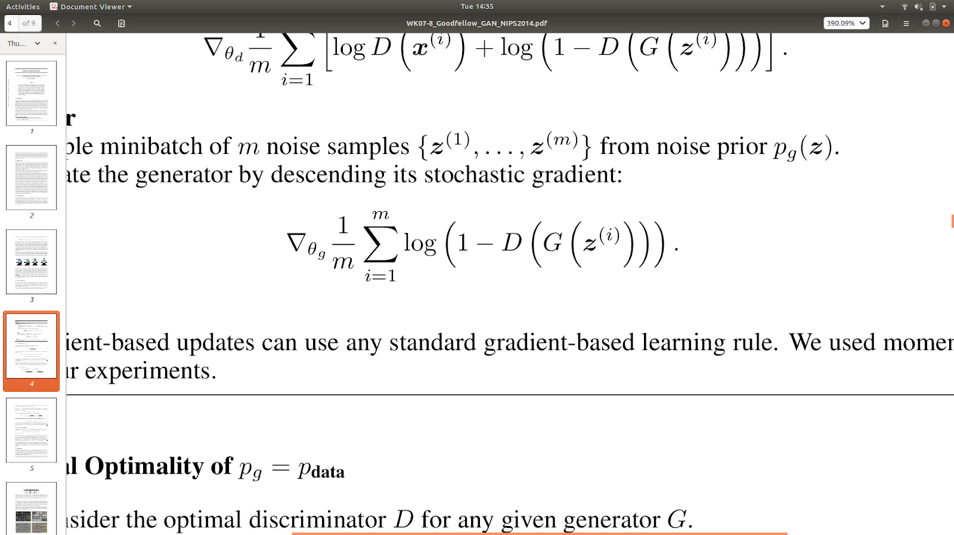

The discriminator is trying to correctly classify images as real or fake and is therefore trying to maximise the function below:

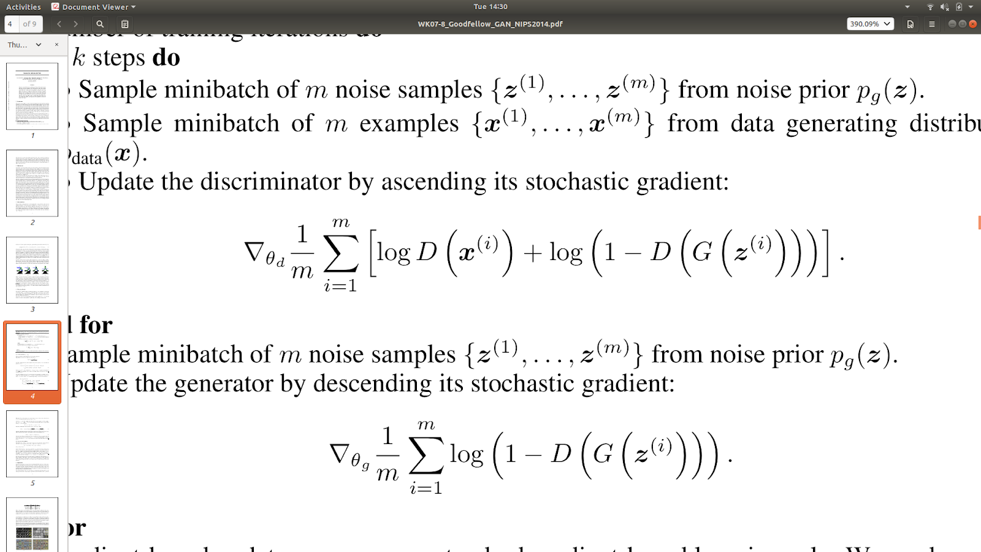

The two have adversarial objectives and they achieve an equilibrium when D(x) = 0.5, I.e the discriminator is unable to distinguish between fake and real images.

(3) The training process for the auto-encoder involves calculating the loss as described above and then updating the encoder and decoder functions appropriately. This continues until the model reaches a minima that it can’t improve on or until you run out of time/computational resources.

The training for the GAN involves continuing the training of the GAN until discriminator function is just as likely to incorrectly classify a fake image as it is a real image. i.e. D(x) = 0.5 . At this point the discriminator can’t tell the difference between the fake and real images.

1. **How is the distribution $p_{g}\left(x\right)$ learned by the generator compared to the real data distribution $p\left(x\right)$ when the discriminator cannot tell the difference between these two distributions? (15% of CW2)**

**When the discriminator can’t tell the difference, the two distributions should be identical. i.e. $p_{g}\left(x\right)$ = $p\left(x\right)$. The discriminator is not able to tell the difference because the generator distribution is identical to the real data distribution.**

1. **Show the generated images at 10 epochs, 20 epochs,50 epochs,100 epochs by using the architecture required in Guidance. (15% of CW2)**

**10th epoch images:**

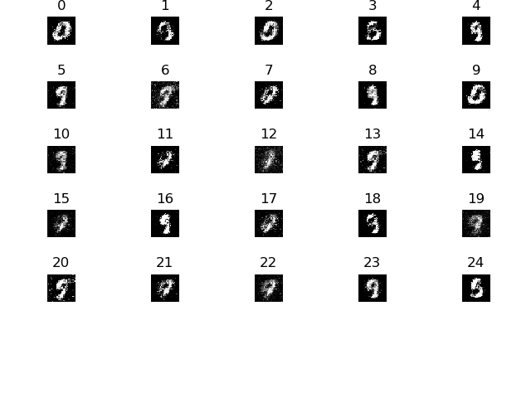

**20th epoch images:**

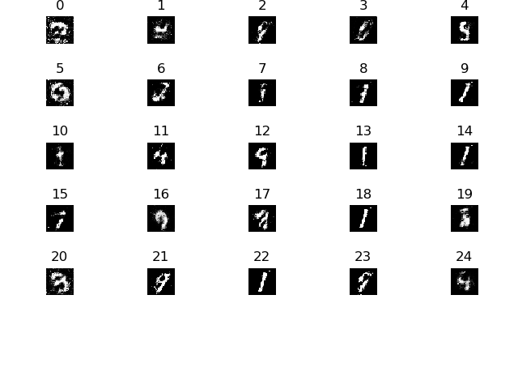

50th epoch images:

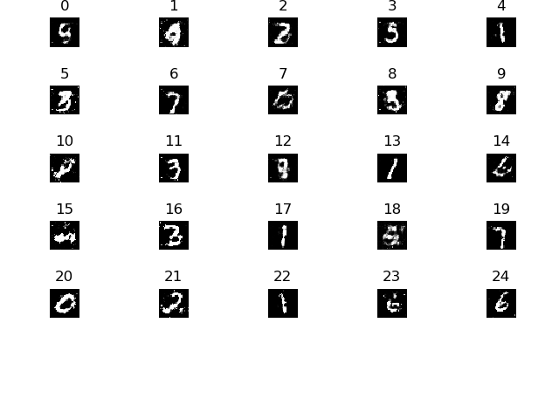

100th epoch images:

